Supply Chain KPI & Inventory Optimization Analysis Report

1. Project Overview
This project analyses end-to-end supply chain data to evaluate product performance, inventory efficiency, and component-level risks. Using SQL, data from sales orders, bill of materials (BOM), and procurement is integrated to generate actionable insights for supply chain decision-making.

2. Objectives
- Monitor and evaluate inventory levels to ensure optimal stock performance
- Analyse order fulfillment and identify potential delays impacting service levels
- Detect risks of stockouts and overstock through data-driven analysis
- Support supply chain decision-making through KPI-driven insights

3. Data Sources
The analysis integrates multiple datasets:
- Sales Orders → Demand data
- Bill of Materials (BOM) → Component usage per product
- Purchase Orders (PO) → Supply data
- Components / Products / Vendors → Master data

📊 4. Key Analysis & Insights

4.1 Product Revenue & ABC Analysis
🔍 Approach
- Calculated total revenue per product using:
  - quantity × unit_price
- Ranked products by revenue contribution
- Applied cumulative revenue logic

📸 Screenshot to include:
- product_id
- total_revenue
- revenue_pct
- sorted descending
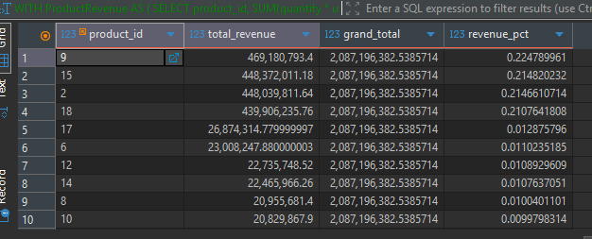

💡 Key Insights
- A small number of products contribute the majority of total revenue
- Revenue distribution follows Pareto principle (80/20 rule)

📈 Business Interpretation
- High-revenue products should be prioritized for:
  - Inventory availability
  - Demand forecasting accuracy
  - Service level monitoring

4.2 Cumulative Revenue (Pareto Analysis)
🔍 Approach
- Calculated cumulative revenue contribution
- Identified % contribution per product
- Determined threshold for top ~80% revenue

📸 Screenshot to include: 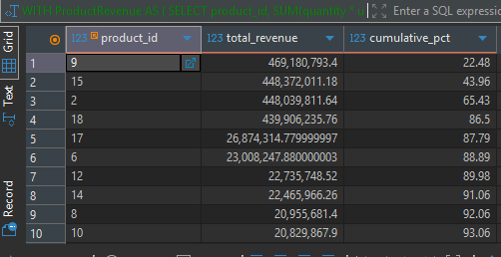
👉 Table showing:
- product_id
- total_revenue
- cumulative_pct

💡 Key Insights
- Top products quickly accumulate to ~80% of total revenue
- Remaining products contribute marginal value

📊 Business Classification
- A Items → Top contributors (high priority)
- B Items → Medium importance
- C Items → Low impact

📈 Business Impact
- Enables targeted inventory planning
- Improves allocation of resources
- Focuses forecasting efforts on critical SKUs

4.3 Component Aging & Inventory Turnover Analysis
🔍 Approach
Integrated:
- Sales Orders → demand
- BOM → component usage
- Purchase Orders → supply
Calculated:
- Total received vs consumed
- Current stock levels
- Inventory turnover rate
Classified components into:
- Slow-moving
- Normal
- Fast-moving

📸 Screenshot to include:
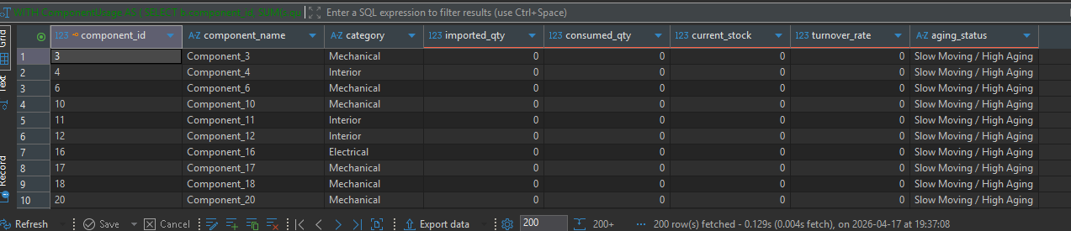
👉 Table showing:
- component_id
- imported_qty
- consumed_qty
- current_stock
- turnover_rate
- aging_status

💡 Key Insights
- Identified components with:
  - Low turnover → excess stock risk
  - High turnover → potential stockout risk

⚠️ Risk Identification
- Slow-moving components
  - Risk of overstock
  - Potential obsolescence
- Fast-moving components
  - Risk of stockouts
  - Require tighter planning

📈 Business Impact
- Reduce excess inventory → improve cash flow
- Optimize procurement decisions
- Improve supply-demand alignment

📊 5. Overall Business Value
This analysis provides:
- Improved visibility into product and component performance
- Identification of inventory inefficiencies
- Data-driven support for:
  - Inventory optimization
  - Demand planning
  - Supplier coordination

🧠 6. Key Takeaways
- Revenue is concentrated in a small subset of products → prioritize them
- Inventory imbalance exists between supply and demand
- Some components show aging risk → opportunity to reduce excess stock
- Data-driven insights can significantly improve planning decisions

